Give the Gift of Travel
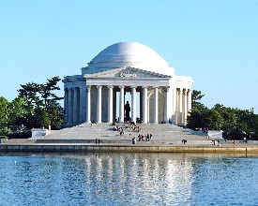
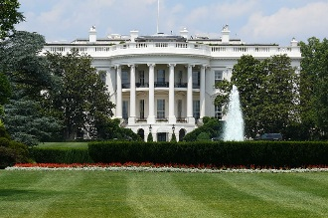
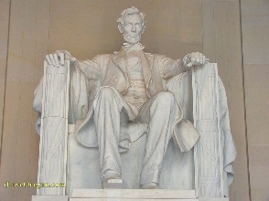
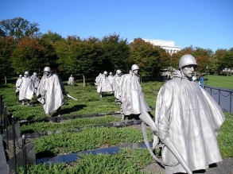
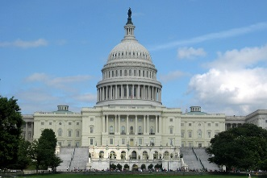

Dear _______________________,
I have the wonderful opportunity to take a once in a lifetime trip with my friends and classmates from ___________________________ to Washington, DC. I will get to see and experience things first hand that up until now, I have only learned about in school.
- Memorials including Vietnam, Korean, Jefferson, FDR, WWII Lincoln, Iwo Jima and MLK
- Smithsonian Museums on the National Mall
- Arlington National Cemetery
- Capitol Hill including the United States Capitol Building, Library of Congress and Supreme Court
- White House
- United States Holocaust Museum

In order to participate in this adventure, I need to raise a total of $________________. Please help make this tour a reality for me by contributing my trip fund. Any amount you can contribute will bring me closer to my goal.

Please call of email me if you have any questions or want to hear more about this really great tour! Hemisphere Educational Travel is the company organizing our tour. You can check them out at www.hemispheretravel.com for more information about their company and practices.

Sincerely,

My contact information:_____________________________________________________________________
- - - - - - - - - - - - - - - - - - - - - - - - - - - - - - - - - - - - - - - - - - - - - - - - - - - - - - - - - - - - - - - - - - - - - - - - - - - - -
Yes, I will contribute!

______$25.00 ______$50.00 ______$75.00 ______$100.00 Other Amount $______

___________________________________________
Contributor’s Name (Please Print)

Please make check payable to Hemisphere Educational Travel

Please return slip and check to:___________________________________________________
(Participant name and address)

